Hayabusa 2 Challenge

Setup Overview
I’m using my Steam KSP build which does not contain any paid DLC in order to complete this mission. The only mods I have are the KSRSS, Scatterer and Deadly Re-entry mods provided as well as a small Camera Tools mod that allows me to take cinematic shots but doesn’t affect gameplay in any way. No paid DLC or parts mods will be used since I like to share out my craft files on the Steam Workshop and KerbalX.com and most players prefer pure stock designs.
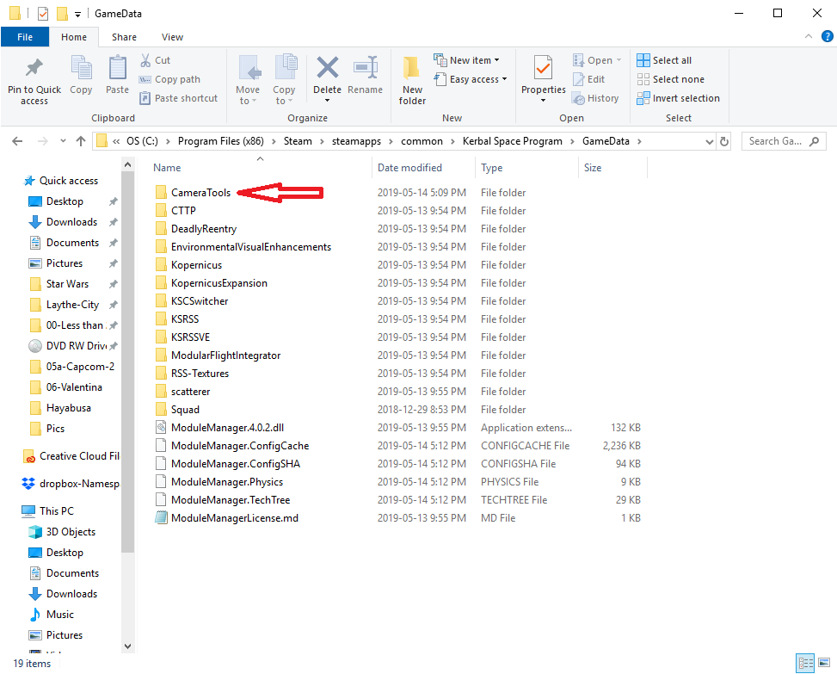
Here is a screenshot of my GameData folder showing all the mods installed
I quite like the mods provided and will likely use them for upcoming projects as well. I like mods that you can download with a single link and this one looks and works great – Thank you!

Design
Since the requirements for completion of the Challenge in Da Vinci class were intentionally vague I decided to put additional restrictions on my submission. These are as follows:
- Pure stock design
- Reusability
As a consequence of these additional restrictions I couldn’t complete the mission using a standard rocket (since the re-entry damage was an issue), and the mission needed to be manned in order to acquire a surface sample in the stock setup for the game. Although I did design and test an unmanned probe mounted on a disposable rocket (which was shown in the video) it was not used party because of the restrictions above, as well as the fact that I wanted to do something really different from most other submissions.
The result was an SSTO Shuttle which needed to be hardened against the heat of re-entry. I tried to keep it as close as I could to a standard space shuttle but minor changes were necessary in order for it to be Single-Stage-to-Orbit, and able to withstand both takeoff and re-entry heating. I’m not sure if this disqualifies my entry, since I noted that the description referred to a rocket launch and not a space plane, but I didn’t see anything that said I couldn’t launch this way.
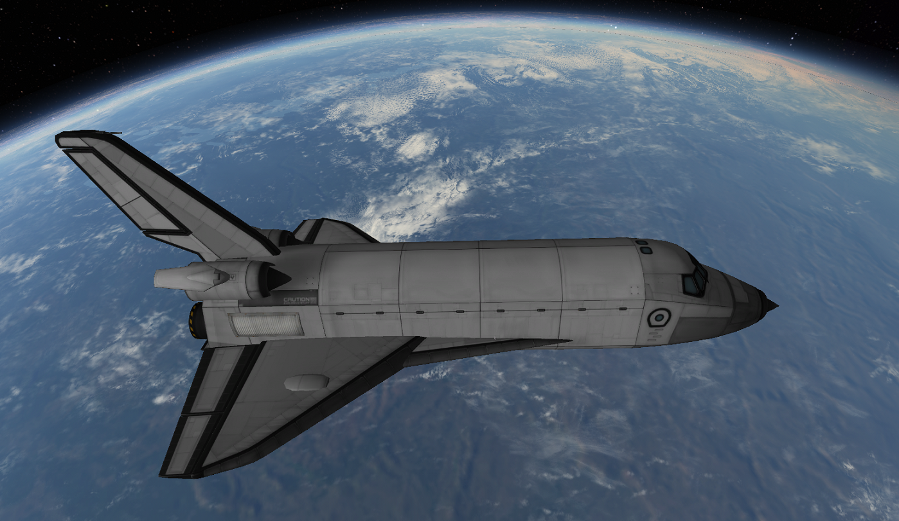
The only thing I wasn’t able to equip on the Hyabusa Shuttle was a ladder, so the Star Coach rover was introduced for loading and unloading of the Kerbals. In addition I found that having an engineer on board helped to manage the heating – which is one of the roles of the engineer class in the game.
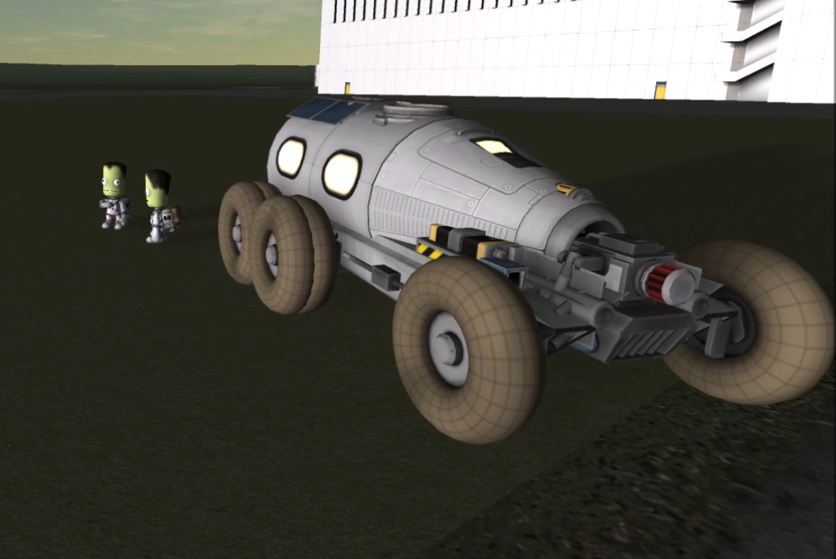
Although the final design is not 100% reusable as shown in the video, the inter-stage was added for ease-of-use in order to avoid multiple long burns in Earth’s shadow to create an escape trajectory out of its gravitational Sphere-of-Influence (SOI) and into interplanetary space. The mission could be completed as shown without the inter-stage booster, but it is much more convenient with the additional thrust for the first burn of the Hasyabusa lander.

Setup
For the initial setup of the mission I used the save game file provide and literally started exactly at the time in the file configuration there may be a more optimal time but I thought it would be best to stick with the default. Some time was taken to load the Kerbals on board the shuttle, but otherwise it started on time.
Like all of my videos, I created a bit of a story line for the mission. There was little mention of the Hayabusa 2 original mission since my flight profile was so different from the actual flight I thought it might confuse my viewers. I like to have a good balance of entertainment and information in my videos which is why I tend to favor long cinematic shots over long descriptions of orbital mechanics. This video does include the basic requirements of orbital burns in a very quick and concise fashion to get the point across without losing the interest of my casual viewers.
Since all of the main characters were available in the save-game file I used all 4 of them to complete the mission. Val piloted the shuttle, Jeb piloted the ion lander, scientist Bob did surface operations on the asteroid Ryugu including a surface sample collection, and Bill provided heat management during the ascent and descent phases of the launch and landing of the shuttle.
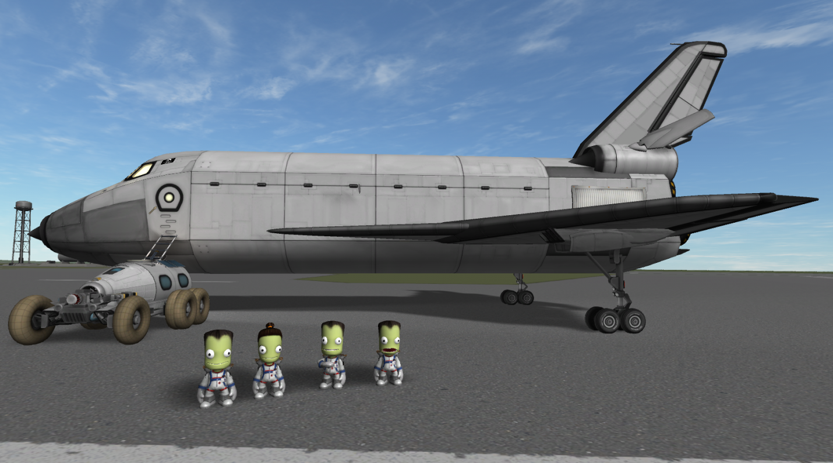
Copies of all the craft files used for the mission are provided and save-game files have also been exported for key points in the mission.

Flight Profile
The Hayabusa Shuttle is an air breathing SSTO and follows the standard profile for launch. Accelerate to the end of the runway and pull the nose up to 15 degrees above the horizon. Continue to accelerate until you run out of air (usually above 21Km altitude) then hit HotKey #1 to switch the Rapier engines to closed-cycle. At this point you can set the direction to the auto-prograde marker to keep on course and continue to burn until the apoapsis rises above 70Km
The orbital insertion burn should leave you with more than enough fuel to do a de-orbit burn and allow the air breathing engines fuel to assist in the landing approach.
After transferring the crew and releasing the lander from the cargo bay through staging, a prograde burn was initiated on the dark side of the planet blasting the lander into interplanetary space and using up all of the liquid fuel and oxidizer in the tank. During the escape trajectory the inter-stage booster was jettisoned through staging.
Once outside of the Earth’s SOI the solar panels could be positioned so that they would receive full sunlight during the maneuvers, to facilitate the electrical requirements of the ion engines during 20- 30 minute burns.
Several burns were initiated in interplanetary space in order to get an intercept with the asteroid Ryugu. The first was a long 21 minute burn in the anti-normal direction to align the orbits along the planetary plane and set up for the intercept node. The best orbital alignment is achieved when the ascending and descending nodes move to a position that is perpendicular to the position of the craft.
The second burn was used to get a close approach to the asteroid. Once the actual maneuver was completed, small additional thrusts were conducted to get an intercept with the asteroids SOI.
This was particularly difficult since the SOI is extremely small (on the order of 20Km in radius), however since the thrust of the ion engines is very small, this allowed for very fine adjustments to the orbit and in the end resulted in a nice intercept.
A third maneuver node was set up very close the asteroid SOI intercept which would match orbits with the target body. This would slow the approach of the lander to the point where there would be enough time for the ion engines to fire and get capture around Ryugu.
As the lander got close to the asteroid, the navigation computer was set to reference the target, and the craft positioned in a retrograde direction. Speed relative to the target was displayed and engine burns could be estimated using that information. A node was set up to reduce the altitude of closest approach and increase the time of the flyby so that the ion engine burn would be sufficient for capture.
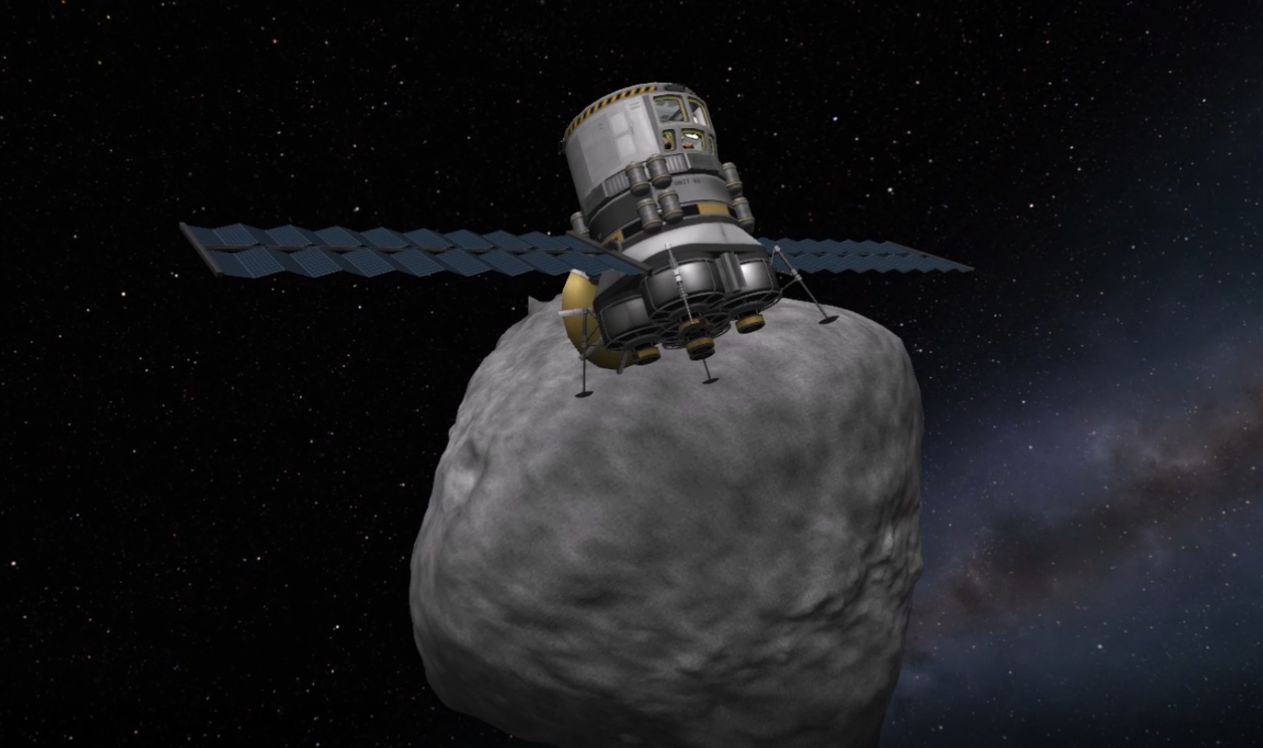
During the process of approach to the asteroid there were a few glitches that showed up one of which caused the navigation screen to show a velocity of 0.0 m/s relative to the target. A save game was initiated and a computer reboot was required to fix the issue (this happened in the real world, but was described in the video as if the Kerbals did it).
Capture and orbit of Ryugu was completed and the save game was archived at that point. Most of the information regarding the orbital maneuvers was captured in the video although very briefly – I need to tell the story using sentences that could generally be read in 4 seconds or less so the amount of information I was able include was minimal.
Descent to the surface of the asteroid was very basic with the craft being set to an auto-retrograde position after a deorbit burn that was only about 2.0 m/s. Surface operations consisted of gathering science from the experiments as well as surface sample collection from an EVA and storing them in the on-board container. I also had a little fun with the Kerbals planting a flag and going on an escape trajectory just to keep things interesting.
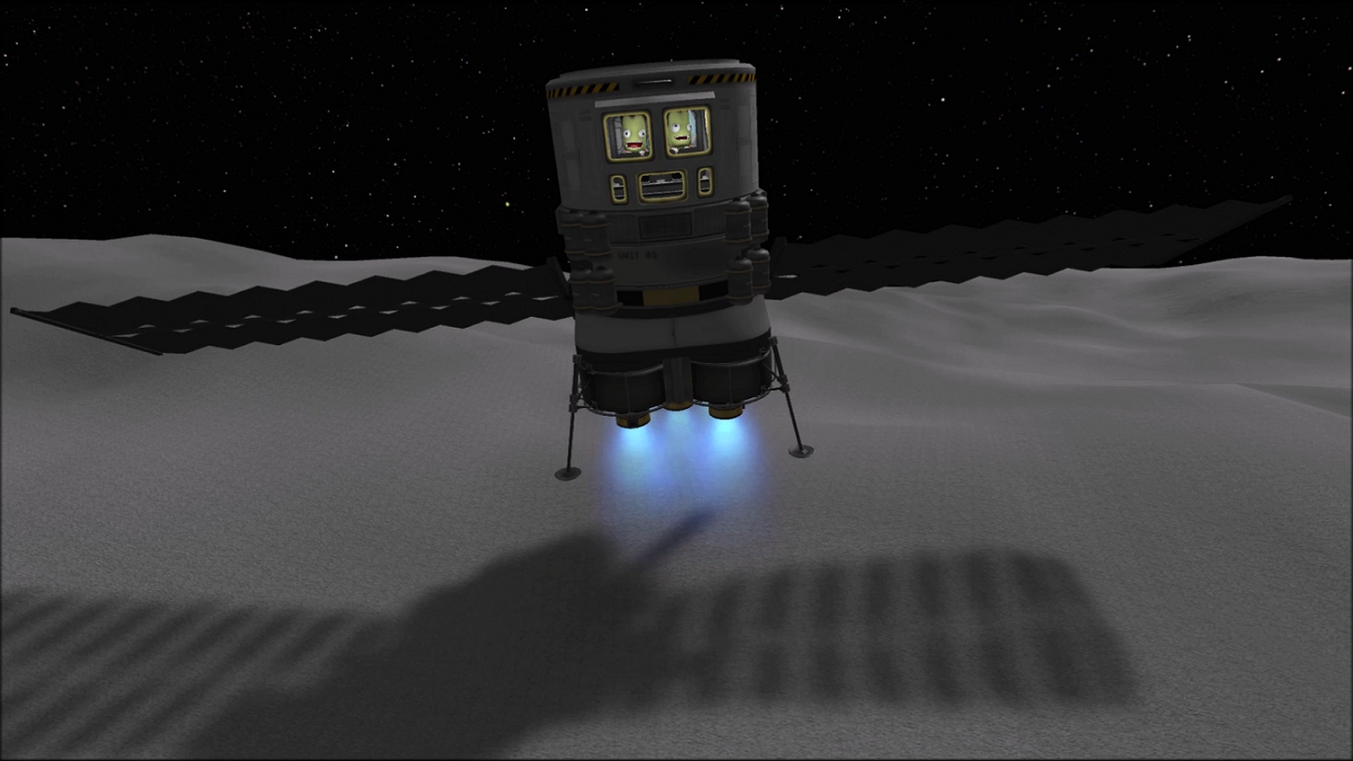
The return trip was basically the reverse of the burns required to get to Ryugu. After a very short engine fire to escape the asteroids SOI, two maneuver nodes were set up in order to get the craft back to the Earth. These were done simultaneously in order to ensure that there would be capture.
Upon getting close to completing the first burn the node was closed and the engine completed firing. Watching the changes in the orbit while keeping the second (orbital alignment) node open showed when an intercept would be achieved with the Earths SOI. The maneuvers were conducted in this way in order to minimise the duration of deep space travel for the two Kerbals cooped up inside the small landing can.
In order to fine tune the Earth approach fly-by I set the focus on the planet and did some fine tune adjustments to the maneuver node by positioning the camera in map view so that I could see both clearly. Additionally, once I completed the burn the ion engines were used to get a good alignment with the orbit of the shuttle in order to facilitate rendezvous and docking.
A number of burns were required for capture, orbital alignment, shuttle intercept and orbit matching. These are similar in nature to what was described for the asteroid intercept so I won’t repeat them here. These are standard orbital procedures, the only caveat in this case is that I tried as much as possible to complete the ion engine burns as short as possible and on the sunny side of Earth.
During docking the ion engines were used to get a close approach to the shuttle and both craft were aligned so that the lander would fit nicely back in the cargo bay. The final capture adjustments were completed using the RCS on board the shuttle.
Jeb and Bill were then transferred back into the shuttle command module and a deorbit burn was completed on the dark side of Earth. The re-entry profile was shallow in order to reduce re-entry heating a much as possible and the shuttle held a position with the nose 20-30 degrees above the horizon during descent.
This caused a slight overshoot of KSC and required the shuttle to turn nearly 180 degrees as it dropped into the lower atmosphere. Although this maneuver was helpful in burning of speed quickly, I would not recommend it as it made alignment with the runway tricky.
During final approach the Rapier engines were switched back to air-breathing mode and the remaining liquid fuel was used to help guide the shuttle on to the runway.
Overall it was a very successful mission returning the craft, crew and science (including a surface sample) back to the Kerbal Space Center happily… except Jeb forgot his flag on the surface of Ryugu so they have to go back!
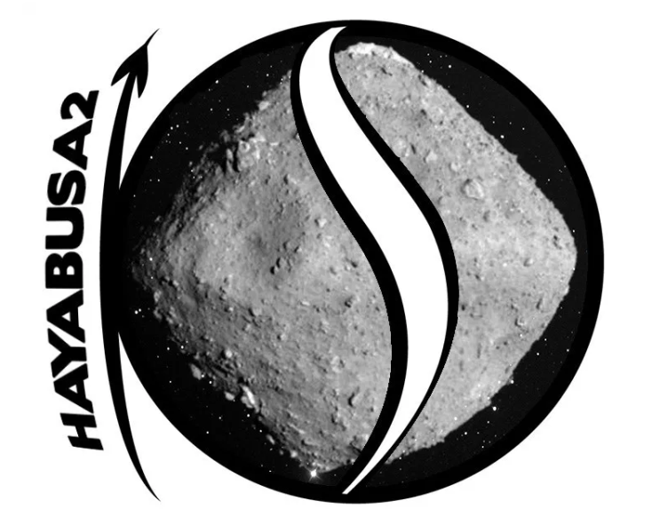
https://www.youtube.com/watch?v=oid3wxiGUDU

